



Performance Evaluation 52 (2003) 133–152

Path selection and bandwidth allocation in MPLS networks
James E. Burnsª, Teunis J. Ottª,1, Anthony E. Krzesinski^{b},∗, Karen E. Mьller^{b}
a Telcordia Technologies Inc., 445 South Street, Morristown, NJ 07960-6438, USA
b Department of Computer Science, University of Stellenbosch, 7600 Stellenbosch, South Africa

Abstract
Multi-protocol label switching extends the IP destination-based routing protocols to provide new and scalable routing
capabilities in connectionless networks using relatively simple packet forwarding mechanisms. MPLS networks carry trafﬁc
on virtual connections called label switched paths. This paper considers path selection and bandwidth allocation in MPLS
networks in order to optimize the network quality of service. The optimization is based upon the minimization of a non-linear
objective function which under light load simpliﬁes to OSPF routing with link metrics equal to the link propagation delays.
The behavior under heavy load depends on the choice of certain parameters. It can essentially be made to minimize maximal
expected utilization, or to maximize minimal expected weighted slacks (both over all links). Under certain circumstances it
can be made to minimize the probability that a link has an instantaneous offered load larger than its transmission capacity.
We present a model of an MPLS network and an algorithm which optimally distributes the trafﬁc among a set of active paths
and reserves a set of back-up paths for carrying the trafﬁc of failed or congested paths. The algorithm is an improvement
of the well-known ﬂow deviation non-linear programming method. The algorithm is applied to compute optimal LSPs for a
100-node network carrying a single trafﬁc class. A link carrying some 1400 routes fails. The back-up paths are activated and
we compare the performance of the path sets before and after the back-up paths are deployed.
© 2002 Elsevier Science B.V. All rights reserved.
Keywords: Internet protocol; Label switched path; Multi-protocol label switching; Quality of service

1. Introduction

The Internet is becoming the ideal platform to support all forms of modern communications including
voice, data and multimedia transmissions. However, the standard IP routing protocols were developed on
the basis of a connectionless model where routing decisions are based on simple metrics such as delay
or hop count which leads to the selection of shortest path routes. Despite its ability to scale to very large
networks, this approach provides only rudimentary quality of service (QoS) capabilities which cannot
be used to provide scalable service level agreements for bandwidth intensive applications in modern
networks.

∗ Corresponding author. Tel.: +27-21-808-4232; fax: +27-21-808-4416.
E-mail address: aek1@cs.sun.ac.za (A.E. Krzesinski).
1 Present address: Department of Computer Science, New Jersey Institute of Technology, Newark, NJ 07102, USA.

0166-5316/02/$ – see front matter © 2002 Elsevier Science B.V. All rights reserved.
PII: S 0 1 6 6 - 5 3 1 6 ( 0 2 ) 0 0 1 7 7 - 3

134

J.E. Burns et al. / Performance Evaluation 52 (2003) 133–152

Multi-protocol label switching (MPLS) [1] extends the IP destination-based routing protocols to provide
new and scalable routing capabilities. MPLS routing/switching is achieved by forwarding IP packets along
virtual connections called label switched paths (LSPs). LSPs are set up by a label distribution protocol
which uses the information contained in layer 3 routing tables. The LSPs form a logical network that is
layered on top of the physical network to provide connection-oriented processing above the connectionless
IP network.
This paper presents a model of ﬂow optimization in MPLS networks. We address the following questions
related to the optimal distribution of trafﬁc ﬂows among LSPs in an MPLS network:
• How is the set of paths computed?
• How is a subset of the computed paths selected to carry the offered trafﬁc?
• How is the trafﬁc distributed among the selected paths?
• How useful are the remaining unselected paths as back-ups to be used in the event of trafﬁc overload
and/or path failure?
We formulate the problem of ﬁnding an optimal set of LSPs and optimally allocating bandwidths to these
LSPs as a constrained non-linear programming problem (NLP) which minimizes an appropriate objective
function. In qualitative terms the goal is to ﬁnd a set of LSPs and a set of target bandwidths for these LSPs
such that if the trafﬁc forecasts are exact and all target bandwidths of LSPs are achieved, the system will
carry all the offered trafﬁc, no link is too heavily utilized, and the carried load is appropriately distributed.
Several previous studies (see [2–4] and the references therein) have formulated the bandwidth allocation
problem in connectionless networks as an NLP using the M/M/1 formula as a penalty function to predict
the queueing delay on individual links, and a load balancing scheme is considered optimal if it minimizes
the total delay over the network. However, the delay in an Internet is limited by the drain time of buffers.
Furthermore, TCP congestion avoidance and random early discard (RED) schemes (see [5,6] and the
references therein) make it possible to have a very high sustained utilization on a link with simultaneously
only moderate packet loss and only moderate variability in buffer occupation. The use of an M/M/1
queueing delay in the penalty function is therefore highly suspect or even incorrect. The issue is not
only that the M/M/1 formula is poor in predicting actual queueing delay, but that queueing delay is
moderately insensitive to trafﬁc intensity on a link. Mechanisms like weighted fair queueing (WFQ) and
class-based WFQ will make the queueing delay even more independent of link utilizations.
Our approach to the NLP and its solution has several novel aspects. First, we present a penalty function
that affords an appropriate representation of the actual quality of the network. Under light load our penalty
function simpliﬁes to OSPF routing with link metrics equal to the link propagation delays. Under heavy
load the behavior depends on the choice of certain parameters. It can essentially be made to minimize
maximal expected utilization, or to maximize minimal expected weighted slacks (both over all links).
Under certain circumstances it can be made to minimize the probability that a link has an instantaneous
offered load larger than its transmission capacity.
Second, we present an efﬁcient technique to solve the NLP. We have adapted an existing solution
technique, namely the ﬂow deviation (FD) method [2–4] to minimize our objective function. Our im-
plementation of the FD algorithm differs from the standard method in that we identify a working set
of LSPs and re-distribute bandwidth over these LSPs until it becomes advantageous to admit new LSPs
to the working set. Appropriate numerical methods and data structures are used to achieve an efﬁcient
implementation of the NLP solver. The advantage of our FD method is that, for the objective function we
use, our FD method is several times faster than the standard FD method.

J.E. Burns et al. / Performance Evaluation 52 (2003) 133–152

135

The FD algorithm computes optimal ﬂows in connectionless networks: the objective function is a sum
of link penalty functions and the ﬂow is optimally allocated among the links. Recently much attention
has been given to adapting optimization algorithms, which were originally developed for circuit switched
operations, so that they can be applied to logically fully connected networks which are layered on top
of connectionless networks. For example, the capacity routing algorithm (see [7] and the references
therein) discovers and capacitates optimal routes in multi-service connection-oriented networks. Here
the objective function expresses an end-to-end service measure such as the call blocking probability.
Bandwidth is optimally allocated among the discovered routes to form virtual path connections which
are either shared among the trafﬁc classes (service integration) or separate VPCs are allocated to each
service class (service separation).
The rest of the paper is organized as follows. Section 2 presents a model of an MPLS network, deﬁnitions
of feasible and optimal LSP bandwidth assignments, a description of the LSP design problem whose
solution yields an optimal set of LSPs and optimal LSP bandwidth assignments, and a description of a
penalty function which under light load simpliﬁes to OSPF routing and depending on certain parameter
choices under heavy load optimizes one of a range of performance criteria. Section 3 describes our
implementation of the FD algorithm to solve the LSP design problem. Section 4 applies the FD method
to compute an optimal LSP set for a model of a 100-node network. The characteristics of the LSP set are
investigated. Our conclusions are presented in Section 5.

2. The model

Consider a communications network with N nodes and L links. Let N = {1, 2, . . . , N } denote the
set of nodes and let L = {1, 2, . . . , L} denote the set of links. The nodes represent the routers in the
MPLS-capable core of a network. Some nodes are connected by a link. The links are directed: each link
has a starting node and an ending node which are routers from the set N.
Each node m ∈ N is both an ingress router and an egress router. Each node is an ingress router because
trafﬁc from the non-MPLS-capable part of the network enters the MPLS network at that point. Each node
is an egress router because trafﬁc to the non-MPLS-capable part of the network exits from the MPLS
network at that point.
Let d(m,n) denote the predicted demand (offered load) of trafﬁc that wants to enter the MPLS network
at node m and wants to exit at node n. We assume that the demands d(m,n) and the link capacities b_{i}are
such that a feasible solution exists. The deﬁnition of feasibility will be given shortly. If a feasible solution
does not exist then systematic drop (discard) of trafﬁc is necessary, and it is an interesting question what
trafﬁc needs to be dropped to minimize the damage. We consider only a single class of service.

2.1. Paths and path bandwidths

A path P is a sequence of links L₁, L₂, . . . , L_{H}P where H_{P}≥ 1 is the hop count of the path P . In our
terminology a route and a path and an LSP are synonymous. No path traverses the same link or the same
node more than once. The algorithms that follow in later sections ensure that no paths contain cycles.
Let P denote the set of all such non-cycling paths. Since any path P contains no cycles, the sequence of
links traversed by a path P can be interpreted as a set denoted by LP . Let P(i) denote the set of paths that
utilize link i. Let P(m,n) denote the set of paths from node m to n with m = n.

136

J.E. Burns et al. / Performance Evaluation 52 (2003) 133–152

2.2. Feasibility and optimality

Each path P will be assigned a target bandwidth BP ≥ 0. The goal is to select these target bandwidths
in an some sense optimal way. Let B = (B_{P})_{P}∈P denote a set of target bandwidths. B is said to be
feasible if the following two constraints hold:
(1) For each pair of nodes (m, n)
∑
BP = d(m,n), (1)
P ∈P(m,n)
so that if the trafﬁc forecasts d(m,n) are exact, and if the target bandwidth is achieved for all paths,
all of the offered trafﬁc is carried.
(2) For each link i
∑
BP ≤ bi, (2)
P ∈P(i)
so that no link has an offered (target) load greater than its capacity.
We next choose a deﬁnition of optimality. Let
∑
fi = BP ,
P ∈P^{(i)}
denote the target ﬂow on link i and let ρi = fi/bi denote the target utilization of link i. Let si = bi − fi
denote the target slack on link i. Constraint (2) implies that all slacks must be non-negative.
Let F_{i}(f_{i}) denote an objective function for link i when the link carries a ﬂow f_{i}. The LSP design
problem is speciﬁed in terms of the following constrained non-linear optimization problem: ﬁnd a set of
feasible target bandwidths B_{opt}that minimizes the objective function
∑

F (B ) =

i
Fi(fi),
(3)

subject to the constraints (1) and (2) where the sum in Eq. (3) is over links i with bi > 0. B_{opt}is said
to provide an optimal solution to Eq. (3). Note that the optimal link ﬂows fi are almost certainly unique
although the optimal bandwidths B are usually not: this matter is discussed in Appendix A.

2.3. The objective function

The link penalty functions Fi(x) used in the LSP design problem have at least three roles. First, they
must to a reasonable degree represent an intuition of what constitutes a “good” load balancing scheme.
Second, they must be an efﬁcient way of managing constraints, in particular the constraint that no link
carries a load larger than, or even close to, its bandwidth. Third, the link penalty functions must make it
possible to efﬁciently ﬁnd an optimal solution to the LSP design problem.
The FD algorithm requires that the link penalty functions Fi(x) be increasing and convex on [0, bi) with
limx↑bi^{F}i(x) = +∞. The latter requirement necessitates a minor change to the deﬁnition of feasibility:
a solution is said to be feasible if fi < bi (strict inequality) on all links i. It is also convenient to make a

J.E. Burns et al. / Performance Evaluation 52 (2003) 133–152

137

slightly stronger demand on the functions Fi(x) and require that each Fi(x) be “strongly monotone” on
the interval [0, bi) so that the objective functions are non-negative on [0, bi) and their derivatives with
respect to ﬂow are positive on (0, bi).
Previous studies of the FD algorithm [2–4] used
Fi(x) = Mi^{x}

bi − x,
(4)

as a link penalty function. If we assume that the offered load to each link i is a Poisson process of packet
arrivals and that packets have independent, identically distributed sizes with exponential distribution and
average Mi, and that there is an inﬁnite buffer, and that the resulting utilization of the link is x/bi, then
the objective function (4) is the product of the ﬂow x and the average delay (waiting and service both
included, but propagation delay excluded). With the M/M/1 assumptions above, the sum of the link
penalty functions is a measure of the average total network delay.
However, in the modern Internet with TCP, and RED and all its variations, it is possible to have very
highly utilized links (utilization practically one) and still low delay and low loss in the buffer: all delay
is moved to the edge of the network. The same holds for example for ATM with ABR, in particular the
ER version of ABR. Eq. (4) is probably no longer a suitable link penalty function. Given these concerns,
we present a link penalty function with properties which make it suitable for use in an objective function
whose minimization will yield routes and bandwidths that correspond closely to the optimal operation of
a modern Internet. Our choice of link penalty function is
( σi ν

Fi(x) = cix + ησi
b_{i}− x
,
(5)

where link i has a bandwidth bi ≥ 0, a weight factor σi > 0 with η > 0, ν > 1 and Fi(x) = ∞ if x ≥ bi.
The factor ci is explained below. The function (5) is strongly monotone and the ﬁrst derivative of the link
penalty function is

F_{i}(x) =^{d}F_{i}(x) = ci + ην
( σi
ν +1

.

(6)

dx
b_{i}− x

Let τi ≥ 0 denote the propagation delay on link i. Set F_{i}(0) = τi. Then ci = τi − ην(σi/bi)ν+1. The
properties of the link penalty function (5) under light and heavy load are discussed in the following
section.

2.4. Behavior under light and heavy load

With reference to the link penalty function (5) we choose η positive but small so that if a feasible
solution exists for which all ﬂows fi are small and all link utilizations fi/bi are low—in which case the
system is said to be uniformly lightly loaded—then the penalty function (5) will yield routes that are in
agreement with OSPF routing where the propagation delays are the OSPF metrics of the links.
If the system is not uniformly lightly loaded then the penalty function enforces a distance from the
barrier bi. The parameter η determines when the barrier begins to dominate the initial linear behavior
of the penalty function. A larger value of η causes the penalty function to rise earlier when the ﬂow
approaches the barrier. The parameter ν determines the behavior of the penalty function as it approaches
the barrier. A larger value of ν makes the penalty function steeper when the ﬂow approaches the barrier.

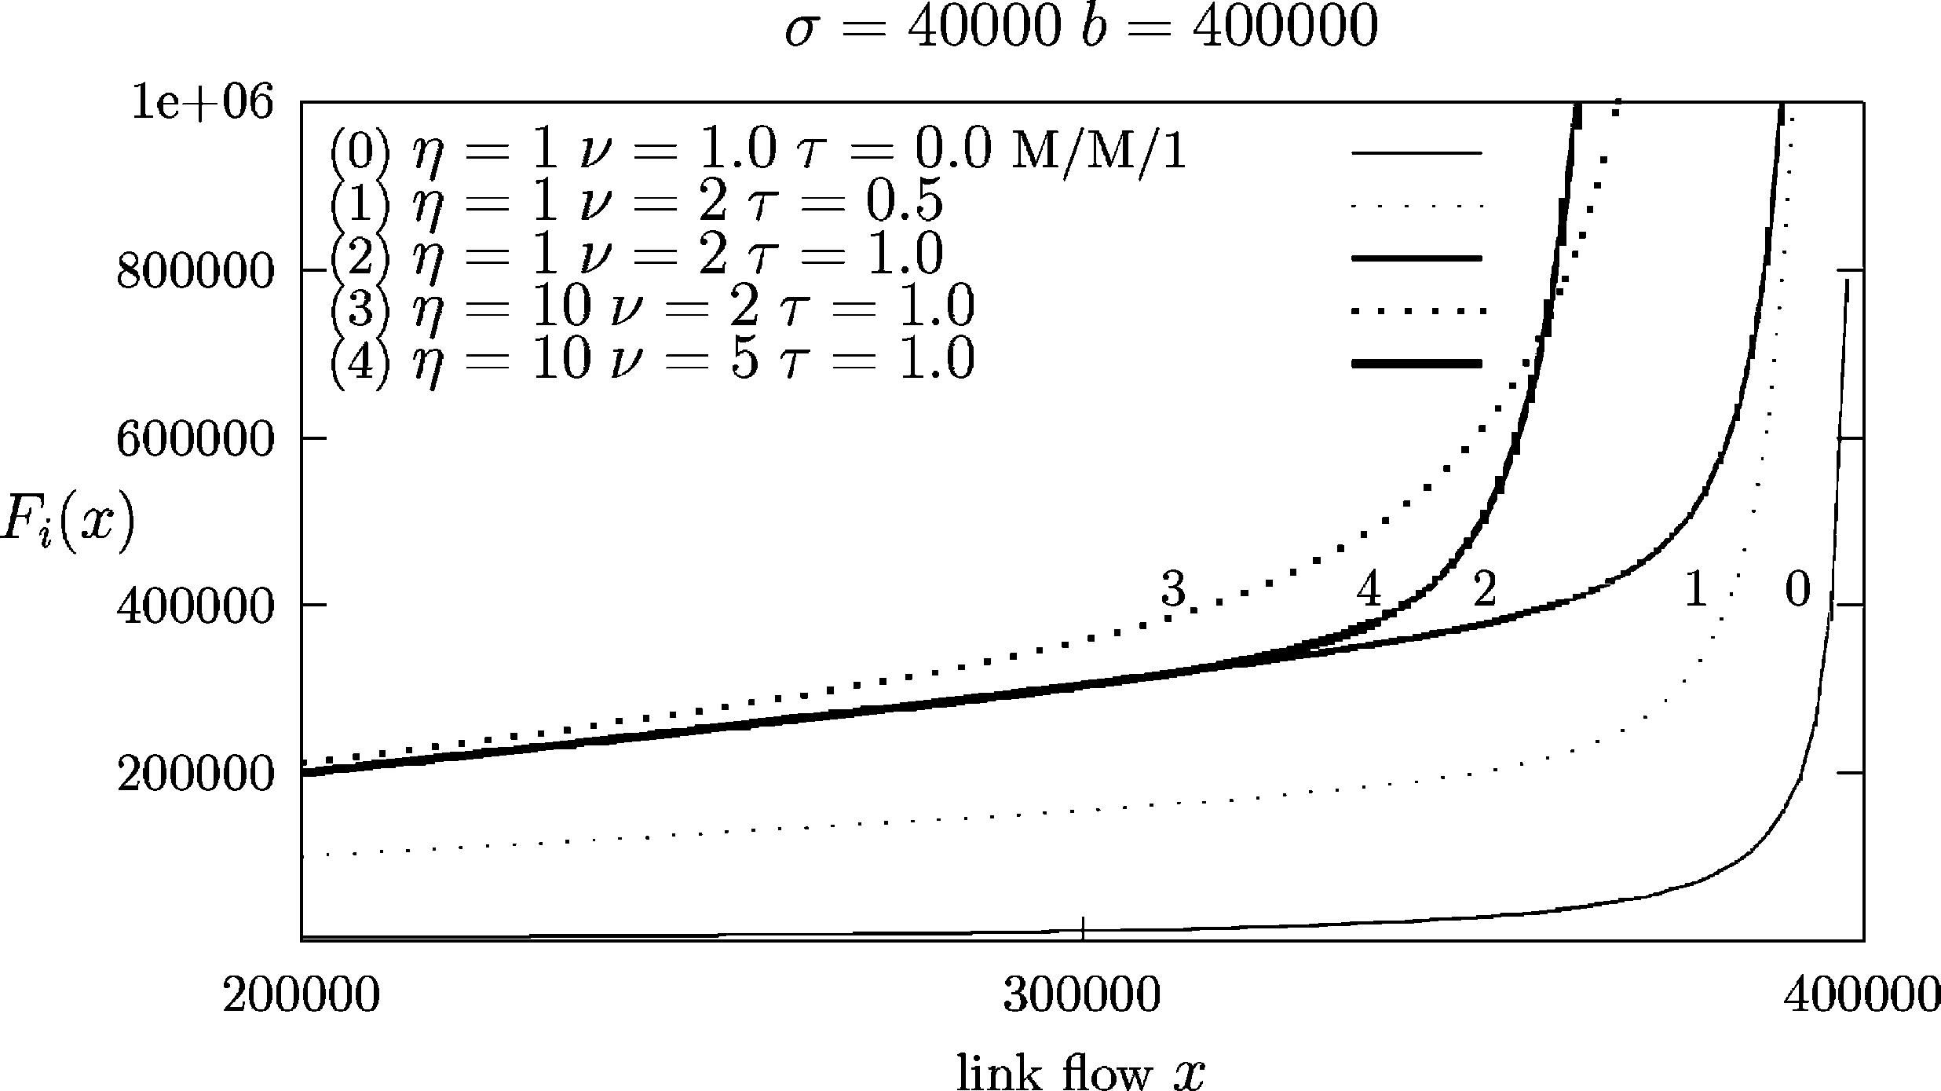

138

J.E. Burns et al. / Performance Evaluation 52 (2003) 133–152

Eq. (6) shows that if ν is large and for some link i the entity

si
σi⁼
b_{i}− fi
σi,

becomes both small in the absolute sense, and also becomes the smallest among all the links, then the
dominating objective of the NLP becomes to increase that entity. We call si/σi the weighted slack of link
i. Thus if ν is large then the NLP maximizes the minimal weighted slack, at least as long as that minimal
weighted slack is small. The magnitude of the minimal weighted slack depends on ν. Even better: as
long as ν is sufﬁciently large, the NLP attempts to perform a “lexicographic maximization” of all small
weighted slacks: ﬁrst it maximizes the smallest weighted slack, then the next smallest, and so on.
The choice of σi is of interest. For example, if we choose σi = bi then we minimize the maximal
utilization, as long as that maximal utilization is large. An interesting situation also arises when all bi
(insofar positive) are large. In that case we can choose for σi an estimate of the standard deviation of the
instantaneous offered load to link i in the situation where the target load is somewhat close to b_{i}. In that
case the weighted slack is the “distance” from the target ﬂow fi to the bandwidth bi, measured in units
of standard deviations. Assuming a Central Limit Theorem, and assuming that the distance as deﬁned
above is at least several standard deviations, then by maximizing the minimal weighted slack we are also
essentially minimizing the maximal probability that the offered load to a link is larger than its bandwidth.
Fig. 1 plots the penalty function (5) of a link i as a function of the link ﬂow x. The link bandwidth
bi = 400,000 and the weight σi = bi/10 = 40,000. These values are related to the parameters of a
50-node network model [8] where the average link capacity is 190,689 ± 81,026 and the average ﬂow
carried on a link is 95,265 ± 48,414.
With reference to Fig. 1 plot (0) shows the M/M/1 penalty function using related parameters. Plots
(1)–(4) are for the penalty function (5). Plot (1) shows the effect of τi = 0.5, η = 1 and ν = 2. Plot (2)
shows the effect of increasing τi from 0.5 to 1.0. The parameter η determines when the barrier bi begins
to dominate the initial linear behavior of the penalty function. Plot (3) shows that the penalty function
begins to rise towards the barrier earlier when η is increased from 1 to 10. The parameter ν determines
the behavior of the penalty function as it approaches the barrier b_{i}: increasing ν increases the steepness
of the rise. Plot (4) shows the effect of increasing ν from 2 to 5.

Fig. 1. Examples of the penalty function.

J.E. Burns et al. / Performance Evaluation 52 (2003) 133–152

2.5. A ﬂow optimization model

139

Path identiﬁcation and trafﬁc distribution are the two most important processes involved in ﬂow opti-
mization. A ﬂow optimization model may be based on either a reactive scheme where path identiﬁcation
and trafﬁc distribution are computed simultaneously to achieve an optimal trafﬁc ﬂow allocation, or a
pre-planned model where path identiﬁcation and trafﬁc distribution are performed separately.
We present a ﬂow optimization model which consists of three parts:
Path identiﬁcation. Path sets are computed for each source–destination pair using a reactive method.
Path selection. The path set is partitioned to yield a set of active paths to carry the offered trafﬁc and a
set of back-up paths for fault recovery or congestion avoidance.
Trafﬁc distribution. The FD model is used to move the offered trafﬁc from higher cost paths to lower
cost paths.
See [9] for a description of a ﬂow optimization model based on a pre-planned path discovery model.

3. The FD algorithm

This section presents an implementation of the FD algorithm [2–4] which minimizes a convex objective
function and thus converges to a global optimum.
The algorithm executes in a loop where each iteration of the loop implements one step of the algo-
rithm. During each step the algorithm computes the current set of shortest (least cost) paths from all
sources to all destinations. An optimal amount of ﬂow is diverted from the current set of LSPs to the
shortest paths. Those shortest paths that are not already in the LSP set are added to the LSP set, the
link costs are updated (the link costs have changed because the link ﬂows have changed) and the next
step of the algorithm is executed. The loop continues until ﬂow re-distribution achieves no further re-
duction in the objective function. A small worked example of the operation of the FD algorithm can be
found in [3].

3.1. The algorithm

In the MPLS context the FD algorithm incrementally improves the set P of LSPs and improves the
distribution of trafﬁc over multiple paths in P from the same source to the same destination. Improving
P mainly consists of adding paths that have, or are likely to have, lower cost than the existing paths from
the same source to the same destination. Improving P may involve discarding paths P that are known
not to have positive BP in any optimal solution, or are not likely to have such a positive ﬂow. Discarding
non-promising paths is not necessary for convergence but signiﬁcantly decreases the computational effort.
The algorithm executes in a loop. Each iteration of the loop implements one step which is identiﬁed
by a step index k:
(1) Initialize. Set k = 0. For each link i set the link ﬂow fi = 0. Compute the least cost path P = Pe(m, n)
connecting each node pair (m, n). Set the target bandwidth BP = d(m,n). If necessary call statement
(6) to enforce a feasible solution. Initialize the path set P = (m,n)^{P}e(m, n).
Statements (2)–(8) given below constitute the body of the loop.

140

J.E. Burns et al. / Performance Evaluation 52 (2003) 133–152

(2) For each link_{L}i compute the link cost C_{i}L = F_{i}(fi). For each path P compute the route cost C_{P}R =
i∈LP^{C}i .
(3) Compute a feasible direction = (∆P )P ∈P and an improved path set P. The calculation of an
improved path set and a feasible direction is discussed in Section 3.2.
(4) Convergence test. If no feasible direction can be found then optimality has been achieved and the
algorithm halts. This stopping rule is theoretically correct but of no practical value. A practical
stopping rule is discussed in Section 3.4.
(5) Compute improved path ﬂows B. Compute a value of x such that BP := BP + x∆P yields a value
F (B) of the objective function which is a strict improvement over the value of the objective function
computed in the previous step, and in the direction is optimal. This computation is called the “line
search” for x. The calculation of x is discussed in Section 3.3. In qualitative terms: a very small
positive x value always gives an improvement. We increase x either until the objective function stops
decreasing, or until a path ﬂow BP goes to zero in which case the path P leaves the set P.
(6) Enforce a feasible solution. If the target bandwidths B are not feasible then for each link i set
bi := αbi, where α = maxi(1.05fi/bi). The solution B is now feasible.²∑
(7) Compute improved link ﬂows. For each link i compute fi := fi + xδi, where δi :=_{P}∈P^{(i)}∆P .
(8) Loop statement: k := k + 1 and go to statement 2.
3.2. Choosing a feasible direction

A feasible direction is a map = (∆_{P})_{P}∈P with the following properties:
• the trafﬁc demand d(m,n) offered to each node pair (m, n) is constant therefore ∑_{P}∈P(m,n) ∆_{P}= 0;
• an empty path cannot have its bandwidth allocation lowered so that if BP = 0 then ∆P ≥ 0;
• a feasible direction will lower the network cost so that P ∈P ∆P C_{P}R < 0.
We present two methods for computing a feasible direction. The ﬁrst method, the so-called global
method, may add paths to the set P. The second method, the so-called local method, does not add paths
to the set P: in fact it is likely to remove paths from P.
3.2.1. The global method
Given a feasible solution B and the current link costs C_{i}L, compute the shortest path Pe(m, n) connecting
each source–destination (S–D) pair (m, n). There may be several such paths in which case a tie-breaking
mechanism is needed. This path may already be in the set of known paths P(m,n) and have a positive ﬂow
B_{P}e(m,n) > 0. If the path is not in P(m,n) then it is added to P(m,n). For each P ∈ P(m,n) compute

∆P =
} −BP ,
P ∈ P(m,n) \ Pe(m, n),

d(m,n) − BP , P = Pe(m, n).
3.2.2. The local method
Given a feasible solution B and the current link costs C_{i}L and the route costs C_{P}R, choose a subset
R(m,n) from P(m,n) for each S–D pair (m, n) as follows: all routes P ∈ P(m,n) with BP > 0 are in R(m,n);
optionally some or all routes P ∈ P(m,n) that have the minimal value of C_{P}R for all P ∈ P(m,n) may be
included, even those with BP = 0; no other paths are included in R(m,n).
2 When the FD algorithm terminates then α = 1 else the solution B is not feasible.

J.E. Burns et al. / Performance Evaluation 52 (2003) 133–152

141

Let R = (m,n)^{R}(m,n) denote the set of active paths. R includes the paths P that have BP > 0 and in
addition R may contain some paths P that, because of their low current cost compared with other active
paths from the same source to the same destination, are likely to be assigned a positive BP .
Let R(m,n) = |R(m,n)| denote the number of active paths that connect node m to n. Let
∑

C | S  (m,n)=

P ∈R(m,n)
C | R  P.

For each P ∈ R(m,n) compute
∆P = C(m,n)^{S}− R(m,n)C_{P}R.

(7)

Thus if there are for example two routes from node m to n then Eq. (7) will decrease the ﬂow on the
more costly route and increase the ﬂow on the cheaper route (at the same rate), and the rates of change
are proportional to the difference in route costs. The ideal situation would be that where all node pairs
(m, n) with two routes will reach their cross-over point where costs become equal at about the same time
(for about the same value of x).
Reducing the size of the path set P substantially improves the performance of the FD algorithm. The
next section describes a method to quickly remove many paths from P that are unlikely to belong to the
ﬁnal optimal set of paths.
The local method: removing inferior paths. Given a feasible direction , compute for each S–D pair
(m, n)

x_{max}R (m, n) =

min
P ∈R(m,n):∆P <0
BP
|∆P |,

(8)

where x_{max}R (m, n) = +∞ if ∆P = 0 for all P ∈ R(m,n). In the line search, if x grows to x_{max}R (m, n)
then the ﬂows on one or more of the routes in R(m,n) will decrease to zero, and that route would be
expelled from P. This mechanism with high probability expels at most one route per iteration. We have
a mechanism to improve this.
Choose a parameter ˆ ≥ 0. For those S–D pairs (m, n) with x_{max}R (m, n) < ˆ we re-scale
R
∆_{P}:= ∆_{P}x_{max}(m, n),(9)

ˆ
for all P ∈ R(m,n). Compute
x_{max}R = minxR

(m,n)
max(m, n),

using the values of x_{max}R (m, n) computed in Eq. (8) with the re-scaled values as computed in Eq. (9).
Now x_{max}R ≥ ˆx and if Eq. (9) is applied at least once then x_{max}R = ˆx . The result now is that no path in R
loses all its ﬂow until x increases to x_{max}R , and for x = x_{max}R a potentially large number of paths all lose
all their ﬂow.
We proceed as follows: initialize ˆ = 0 so no re-scaling occurs after Eq. (7) has computed a feasible
direction . If Eqs. (11) and (12) below determine x = x_{max}= x_{max}R (i.e. the optimal x is one that causes
elimination of at least one route), calculate
ˆ = 2x_{max}R,

142

J.E. Burns et al. / Performance Evaluation 52 (2003) 133–152

for use in the next iteration of the FD algorithm. Else (if the optimal value of x does not cause elimination
of any route) we set ˆ = 0 for the next iteration of the FD algorithm. Once the correct set of paths has
been found, ˆ is likely to remain at zero.

3.2.3. A mixed method
It is likely that in the optimal solution each S–D pair (m, n) will be connected by a small number of
paths P ∈ P(m,n) and these paths will all have the same route costs. It is to be expected that after a while
the shortest path algorithm will keep returning paths from that small set. Once the algorithm is in this
situation the use of the local method seems preferable.
The local and global methods can be combined as follows. The FD algorithm initially iterates using
the global method until the shortest path algorithm ﬁnds no new paths.
The FD then alternates between the local and the global methods as follows: an iteration of the global
method is followed by k iterations of the local method (k ≥ 0) and then another iteration of the global
method. If that new iteration of the global method ﬁnds a new path, it is followed by zero iterations of
the local method. Otherwise, it is followed by k + 1 iterations of the local method.
The algorithm thus alternates between the global and local methods until the stopping rule in Section
3.4 below is triggered.

3.3. The line search

In this section we compute a value of x which yields an improved solution

BP (x) = BP + x∆P ,
for all P ∈ P. Deﬁne
(10)

x_{max}L = min
i:δi>0
si
δ_{i},

where x_{max}L = +∞ if δi ≤ 0 for all i. If x grows to x_{max}L < ∞ then the slack on one or more links will be
equal to zero. Thus we have the constraint x < x_{max}L . Next deﬁne

x_{max}R = min
P :∆P <0
BP
|∆P |.

It is impossible that ∆P ≥ 0 for all P . If x grows to x_{max}R then the ﬂows on one or more routes in P will
decrease to zero. Thus we have the constraint x ≤ x_{max}R.
Set x_{max}= min(x_{max}L , x_{max}R ). With an abuse of notation, we wish to ﬁnd a value of x ∈ [0, x_{max}] which
minimizes
∑

F (x) =

i
Fi(fi + xδi).

Setting y = fi + xδi and taking derivatives we obtain

F (k)(x) =
(

d
dx
(k)

F (x) =
∑

i

(δi)k
(

d
dy
(k)

Fi(y).

J.E. Burns et al. / Performance Evaluation 52 (2003) 133–152

143

Since the functions Fi(·) are strongly monotone, even derivatives of F (x) are positive and odd derivatives
of F (x) are strictly increasing. If

x_{max}R < x_{max}L ,
then x_{max}= x_{max}R . In that case, compute
F (x_{max}) = F⁽1)_{(x}max^{).}
(11)

(12)

If Eq. (11) holds and F (x_{max}) ≤ 0 then x_{max}is the optimal value for x. In this case, in updating the
feasible solution, one or more routes have their ﬂow reduced to zero and these routes may be removed
from P.
If Eq. (11) does not hold, or if it holds but F (x_{max}) > 0 then we need to ﬁnd the value of x ∈ [0, x_{max})
where F (x) = 0. Because the even derivatives of F (x) are positive we can use the Newton–Raphson
method [10] to ﬁnd the value of x .

3.4. The stopping rule

The algorithm requires a stopping rule to determine the iteration k when the algorithm has converged.
We can stop when either |F (xk+1⁾− F (xk )| or |xk+1 − xk | has been close to zero for some time in
which case further iterations will yield no improvement in the solution. We can use a combination of
these two criteria. Because even derivatives of F (·) are positive, the sequence (xk ) will become monotone
decreasing or increasing. It may be safe not to stop until the sequence has been monotone for some time
and one or both of the other conditions above is satisﬁed.

3.5. Comparing the local and global methods

3.5.1. The global method
The global method computes the shortest paths between all S–D pairs each time a new feasible direction
is calculated. The shortest path calculation has complexity O(N³) where N is the number of nodes in the
network. After each shortest path calculation the global method needs to check if the shortest paths are
already in the set P.
The choice of direction can lead to convergence problems. For many S–D pairs there are, in the optimal
solution, several paths with equal costs and each path carries a signiﬁcant ﬂow. When close to the optimal
solution, one of these paths will have the least cost. The global method will move ﬂow from the slightly
more costly path to the slightly less costly paths. With high likelihood, in the next iteration the previous
slightly more costly path has become the slightly less costly, and the direction of the transfer of ﬂow is
reversed: the algorithm oscillates.

3.5.2. The local method
The local method for choosing a feasible direction has computational complexity O(R(m,n)) per S–D
pair (m, n).
Paths which are likely not to carry a ﬂow in an optimal solution are removed from the set of active
ﬂows by driving their ﬂows to zero. If we had not used the reﬁnement introduced in Section 3.2.2 then
with near certainty the local method will remove one path per iteration or worse: not every iteration need

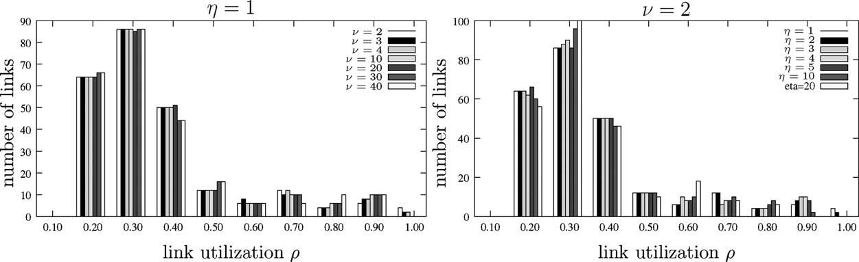

144

J.E. Burns et al. / Performance Evaluation 52 (2003) 133–152

to eliminate one such ﬂow. If there were a large number of such ﬂows this could, in the absence of the
above reﬁnement, cause a major slow-down in the algorithm.

3.6. Implementation issues

Each time the global method is invoked it calculates the shortest paths connecting all S–D pairs and
checks whether the current set of shortest paths is already in P. These calculations are computationally
expensive. The shortest paths are computed using Floyd’s algorithm (see [11]) and the references therein
for a discussion of the relative merits of several well-known shortest path algorithms. Each path P is
stored in a table which is accessed via a hash index computed over the link set LP .

4. An application

This section presents a numerical study of MPLS path selection in a model of a 100-node network
with 244 uni-directional links and one trafﬁc class. The links are capacitated with 6,515,881 units of
bandwidth: the average link capacity is 26,704 ± 19,320 units of bandwidth. A total of 250,000 units of
ﬂow are offered to the 9900 S–D pairs. A description of the model with link capacities and offered trafﬁcs
can be found at the URL http://www.cs.sun.ac.za/projects/COE/models.zip.

4.1. The choice of penalty function parameters

Fig. 2 compares the link utilization distributions computed by the global FD method for several values
of the penalty function (5) parameters η and ν. Given that the link utilization distribution (for the 100-node
model) is relatively insensitive to the values of η and ν, the results presented in the rest of this section are
for η = 1, ν = 2, τi = 1 and σi = bi/10.

4.2. The Kleinrock (K) versus the Bertsekas–Gallager (B–G) methods of FD

Two variants of the standard FD algorithm have appeared in the literature. Kleinrock’s implementation
[4] uses a line search to compute the optimal amount of ﬂow to move, and ﬂow is moved for all S–D pairs at

Fig. 2. Distribution of the link utilization ρ.

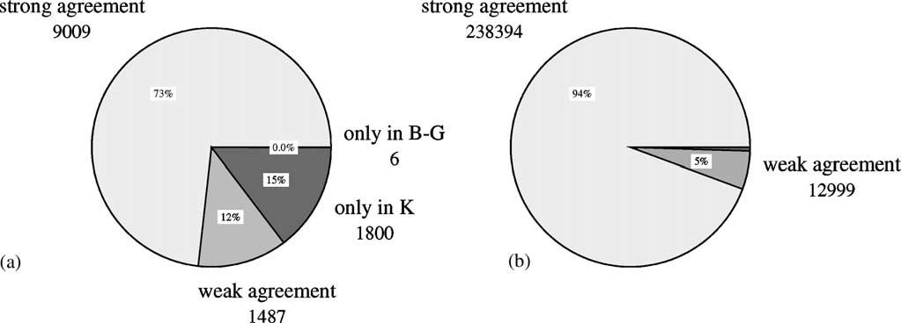

J.E. Burns et al. / Performance Evaluation 52 (2003) 133–152

Fig. 3. Commonality among the (a) paths and (b) path ﬂows computed by the K and the B–G FD algorithms.

145

once. Bertsekas and Gallager [2] developed a variant of the FD algorithm which avoids a computationally
expensive line search and instead estimates the amount of ﬂow to be moved—the ﬂow is moved for one
S–D pair at a time. The main advantage of the B–G algorithm is that it is computationally less expensive
than Kleinrock’s algorithm and it computes better values for small moves near the optimal point where
Kleinrock’s algorithm can oscillate. Kershenbaum [3] developed a technique for scaling the link capacities
to enforce feasible solutions: we use this technique since it is effective and simpler than the search for
feasible solutions presented in [4].
Fig. 3 investigates the commonality among the active path sets found by the K and the B–G FD
algorithms. Consider a path P that is present in both the K and the B–G path sets. Let FP and F P denote
the ﬂow on path P when path set is computed using the K and the B–G FD algorithms respectively. If
|FP − F_{P}| < 0.05 then the path P is said to be in strong agreement among the K and B–G path sets, else
the path P is said to be in weak agreement. Fig. 3 shows that 73% of the paths are in strong agreement:
the ﬂows on these paths are the same to within 5% in the K and B–G solutions. 12% of the paths are in
weak agreement. Kleinrock’s algorithm ﬁnds 1800 paths that do not occur in the B–G path set, but these
paths carry a trivial ﬂow. Likewise six paths in the B–G path set do not occur in the K path set, but these
paths also carry a trivial ﬂow. The additional routes with minimal ﬂow discovered by Kleinrock’s method
can be useful as back-up routes.
We conclude that, for the 100-node model, the K and B–G FD algorithms discover equivalent path sets
once the trivial routes are discarded from the K path set. In the remainder of this section will therefore
use the B–G algorithm as the basis for our global and mixed FD algorithms. Note again that the optimal
paths sets are usually not unique: this matter is discussed in Appendix A.

4.3. The effect of the penalty function

We next investigate whether the global FD algorithm using the penalty function (5) succeeds in com-
puting a ﬂow distribution which maximizes the minimum slacks of the network links. The calculation of
a set of link ﬂows which maximizes the minimum slacks was formulated as a linear programming (LP)
problem and the optimal routes and route ﬂows were extracted from the optimal link ﬂows [12].
Fig. 4 investigates the commonality among the active path sets found by the FD and the LP methods.
51% of the paths are in strong agreement: the ﬂows on these paths are the same to within 5% in the FD
and LP solutions. 18% of the paths are in weak agreement. 25% of the FD paths do not occur in the LP

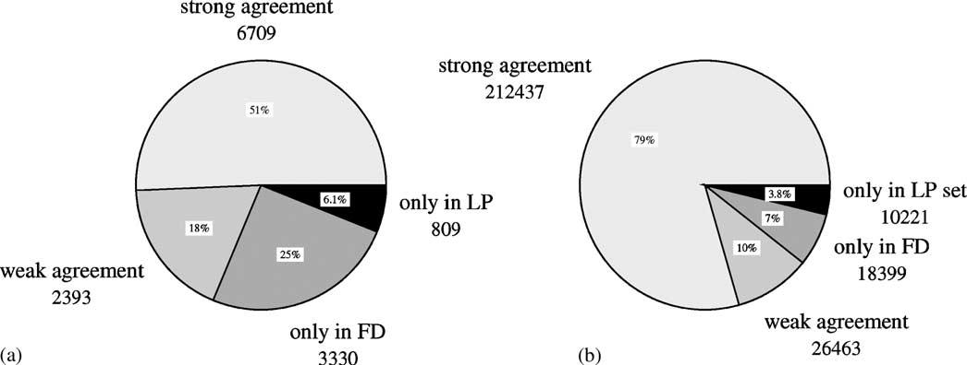
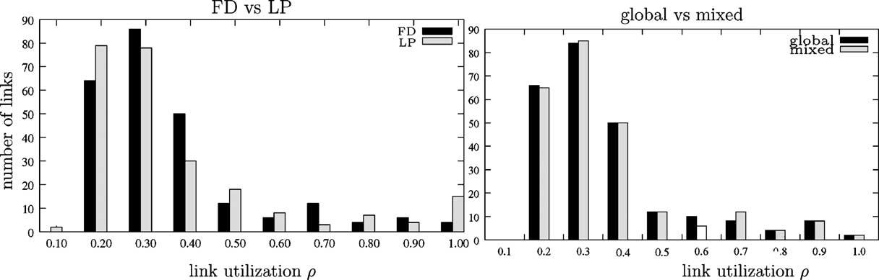

146

J.E. Burns et al. / Performance Evaluation 52 (2003) 133–152

Fig. 4. Commonality among the (a) paths and (b) path ﬂows computed by the FD and LP methods.

path set, but these paths carry only 7% of the ﬂow in the FD model. 6% of the LP paths do not occur in
the FD path set, but these paths carry only 4% of the ﬂow in the LP model. 89% of the ﬂow is distributed
among paths that are present in both the LP and the FD path sets, and 80% of the ﬂow is carried on paths
that are in strong agreement.
Fig. 5(a) compares the link utilization distributions computed by the FD and LP methods. The two
distributions are in good agreement though the LP method yields a few more under- and over-utilized links.
From our comparison of the LP and FD link and path ﬂows we conclude that for the 100-node model
and for the parameter values being used, the LP and FD path sets are largely equivalent: the FD algorithm
using the penalty function (5) has succeeded in computing a ﬂow distribution which maximizes the
minimum slacks of the network links.

4.4. The global versus mixed FD methods

We next compare the qualities of the active path sets as computed by the global and the mixed FD
methods. The global method requires some 15 s of CPU time on an AMD6 1.8 GHz processor to solve

Fig. 5. Distribution of the link utilization ρ computed by (a) the global FD and the LP methods (b) the global and the mixed FD
methods.

J.E. Burns et al. / Performance Evaluation 52 (2003) 133–152

147

the LSP design problem for the 100-node model; the mixed method requires some 10 s. Fig. 5(b) shows
that the global and mixed methods yield nearly the same link utilization distributions.
In the remainder of this section, the length of a path denotes the hop count of a path. The normalized
length of a path is the length of that path minus the length of the shortest path connecting the S–D pair
of that path.
The global method ﬁnds an optimal LSP set containing 10,502 routes. The average normalized route
length is 0.39 and the average LSP bandwidth is 23.8. The mixed method ﬁnds an optimal LSP set
containing 10,681 routes. The average normalized route length is 0.38 and the average LSP bandwidth is
23.4. The LSP sets have several attractive features. The LSPs overwhelmingly coincide with the shortest
routes connecting the S–D pairs. Most S–D pairs are connected by one or two LSPs. Some 95% of the
ﬂow is assigned to the shortest LSPs.
Table 1 shows the ﬂow assigned to n-path connections where n = 1, 2, 3, 4 (a S–D pair is said to
have an n-path connection or a path multiplicity of n if the pair is connected by n LSPs). For example
the second row of Table 1 shows that 584 S–D pairs are connected by two routes: the 1168 routes carry
12,193 units of ﬂow which is 4.8% of the total ﬂow carried by the network. Each of these routes carries
on average 10.4 units of ﬂow. Each two path connection carries on average 20.8 units of ﬂow. The global
method yields an average path multiplicity of 1.06. The mixed method yields an average path multiplicity
of 1.08.
Fig. 6 investigates the commonality among the active path sets found by the global and the mixed FD
methods. Fig. 6 shows that 84% of the paths are in strong agreement: the ﬂows on these paths are the
same to within 5% in the global and the mixed solutions. 9% of the paths are in weak agreement. 3% of
the global paths do not occur in the mixed path set, but these paths carry a trivial ﬂow. 4% of the mixed
paths do not occur in the global path set, but these paths carry a trivial ﬂow. 99% of the ﬂow is distributed
among paths that are present in both the global and the mixed path sets, and 95% of the ﬂow is carried
on paths that are in strong agreement.
Table 1, Figs. 5(b) and 6 conﬁrm that the LSP sets computed by the global and mixed FD methods are
nearly equivalent. Given the good agreement between the solutions for the 100-node model as computed
by the global and mixed methods, the results presented in the rest of this section are computed by the
global method since this method, though less efﬁcient than the mixed method, computes optimal as
opposed to near-optimal path sets.

Table 1
Path multiplicity

Path multiplicity
Global method
1
2
3
Mixed method
1
2
3
4
S–D pairs

9307
584
9

9141
738
20
1
S–D routes

9307
1168
27

9141
1476
60
4
Flow

237690
12193
103

236466
13457
220
8
%

95.0
4.8
0.0

94.5
5.3
0.0
0.0
Flow/route

25.5
10.4
3.8

25.8
9.1
3.6
2.0
Flow/S–D

25.5
20.8
11.5

25.8
18.2
11.0
8.3

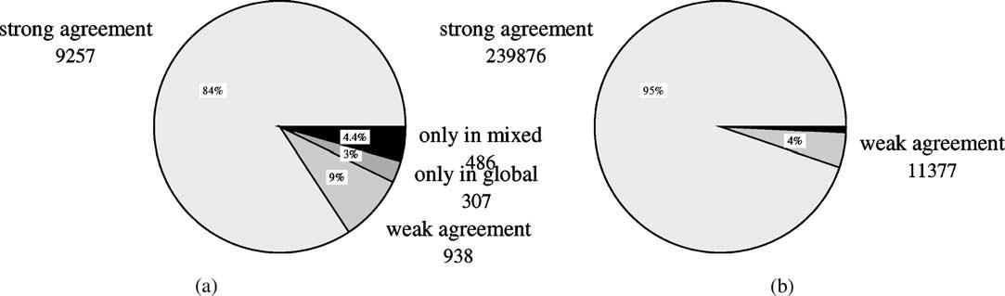

148

J.E. Burns et al. / Performance Evaluation 52 (2003) 133–152

Fig. 6. Commonality among the (a) paths and (b) ﬂows computed by the global and the mixed FD methods.

4.5. Back-up paths

MPLS-based recovery is intended to effect rapid and complete restoration of trafﬁc affected by a fault
in an MPLS network [13]. Two recovery models have been proposed for MPLS networks: re-routing
which establishes recovery paths on demand, and protection switching which works with pre-established
recovery paths. IP re-routing is robust and frugal since no resources are pre-committed but is inherently
slower than protection switching which is intended to offer high reliability to premium services where
fault recovery takes place at the 100 ms time scale.
This section presents a simple model of protection switching in MPLS networks. The FD method is
used to ﬁnd and capacitate a set of optimal LSPs which constitute the working (active, primary) LSPs.
Global repair is implemented by reserving a set of LSPs for use as pre-established recovery (back-up,
protection) paths. In many cases a working path and its protection counterpart are link disjoint to protect
against link failures.
The FD algorithm computes an active path set for the 100-node model consisting of 10,502 routes
carrying 249,987 units of ﬂow. The algorithm identiﬁed 8609 routes to which ﬂow was not assigned:
these routes are designated as back-up paths. These paths provide back-up for 50% of the S–D pairs
which offer 33% of the trafﬁc to the network. 12% of the back-up paths are link disjoint with their
working counterparts.
A back-up path should be provided for each S–D pair. In [9] we describe the K shortest path (KSP)
method for computing a set of link disjoint paths connecting each S–D pair. A set Q of back-up paths
that covers all the S–D pairs is found by taking the union of the set Pback-up of back-up paths discov-
ered by the FD algorithm and the set P_{KSP}of KSP paths with the set Pactive of active paths removed.
Thus
Q = Pback-up ∪ (P_{KSP}\ Pactive^{).}
The combined path sets yield a total of |Q| = 18,349 back-up paths.
Fig. 7(a) presents the distributions of the normalized lengths of the active paths and the back-up paths.
Most of the active paths are of normalized length 0 and are thus the shortest paths between their respective
S–D pairs. This implies that the active paths make efﬁcient use of the link bandwidth. Although many of
the back-up paths have a normalized length 0, some of the back-up paths have a large normalized length
and do not make efﬁcient use of the link bandwidth.

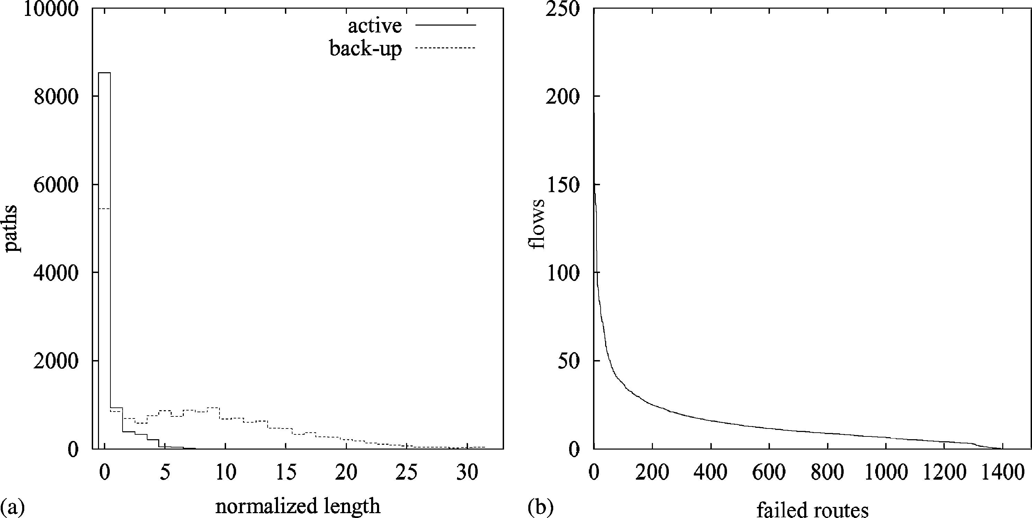
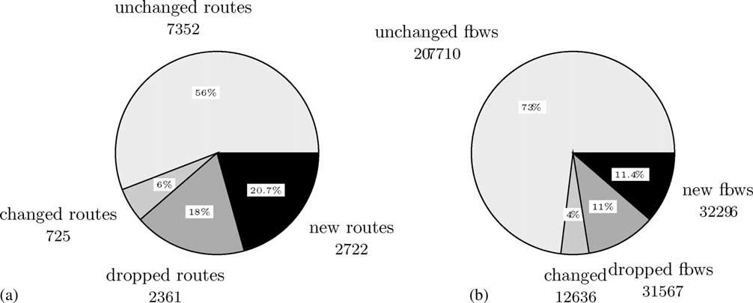

J.E. Burns et al. / Performance Evaluation 52 (2003) 133–152

Fig. 7. (a) Normalized lengths of active and back-up paths; (b) ﬂows on failed routes.

149

The most active link—though not the most heavily utilized link—in the 100-node network carries 1393
routes (13% of the network routes) and 21,228 units of ﬂow (8% of the network ﬂow). The failure of
this link is modeled by setting the cost of this link to a very large positive number. Fig. 7(b) presents the
distribution of the ﬂow on the failed routes. The FD algorithm is then executed with the back-up path
set Q as input. The FD algorithm can assign ﬂow to the back-up paths. However, the algorithm may
determine that some back-up paths are not optimal and in this case the algorithm will ﬁnd and use new
paths.
Fig. 8 compares the performance of the path sets before and after the link failed. Fig. 8(a) shows
that 62% of the routes that were present before the link failed remain in use after the link failed.
2361 routes were dropped: the dropped routes include the 1393 failed routes that passed through the
failed link as well as other (discarded) routes that are no longer used once the ﬂow was optimally di-

Fig. 8. Commonality among the (a) paths and (b) ﬂows after a heavily utilized link has failed and the back-up paths are deployed.

150

J.E. Burns et al. / Performance Evaluation 52 (2003) 133–152

verted to avoid the failed link. 2722 new routes were used to carry the diverted ﬂow: 1296 of these
routes are back-up routes and 1453 are new routes. Many of the back-up routes were therefore not
used.
Fig. 8(b) shows that 73% of the route ﬂows are in strong agreement before and after the link failed:
the ﬂows on these routes are, to within 5%, undisturbed by the link failure. 4% of the routes are in
weak agreement: their ﬂows have changed by more than 5%. 31,567 units of ﬂow were moved from the
dropped routes: 21,228 units of ﬂow were moved from the failed routes and 10,339 from the discarded
routes. 32,296 units of ﬂow were moved to back-up paths and to newly discovered paths. Of this amount,
17,400 units of ﬂow were assigned to the back-up routes and 14,896 units of ﬂow were assigned to new
routes.

5. Conclusion

This paper considers the problem of optimal path selection in MPLS networks. The problem is formu-
lated as the minimization of a non-linear objective function which under light load simpliﬁes to OSPF
routing with link metrics equal to the link propagation delays, and under heavy load minimizes the prob-
ability that a transmission link has an instantaneous offered load larger than its bandwidth. We present an
efﬁcient algorithm based on the FD method to ﬁnd the optimal paths and to assign optimal bandwidths
to these paths. The algorithm also discovers a set of back-up paths for carrying the trafﬁc of failed or
congested paths. The algorithm is applied to compute optimal LSPs for a 100-node network carrying a
single trafﬁc class. We show that the FD algorithm, using the given objective function, computes a ﬂow
distribution that is consistent with the goal of maximizing the minimum slacks on the network links. We
investigate several variants of the FD algorithm and show that they compute near identical ﬂows. Finally
we investigate the utility of the back-up paths. A heavily utilized link carrying some 1400 routes fails:
the back-up paths are activated and we compare the performance of the path sets before and after the
back-up paths are deployed.

Acknowledgements

This work was supported by grants from the Telcordia Research Horizons Programme, the South
African National Research Foundation, Siemens Telecommunications and Telkom SA Limited.

Appendix A. Path sets and route degeneracy

The optimal solution B computed by the FD algorithm is not unique. For example consider the network
[1] presented in Fig. A.1 where trafﬁc is offered from nodes 1 and 2 to node 6: the trafﬁc demands are
d(1,6) = 0.5 and d(2,6) = 1.5. All links have capacity bi = 2 and have the same propagation delay and the
same weight factor. The optimal link ﬂows are

f(1,3) = 0.5, f(2,3) = 1.5, f(3,4) = 1.0, f(3,5) = 1.0, f(4,6) = 1.0, f(5,6) = 1.0.

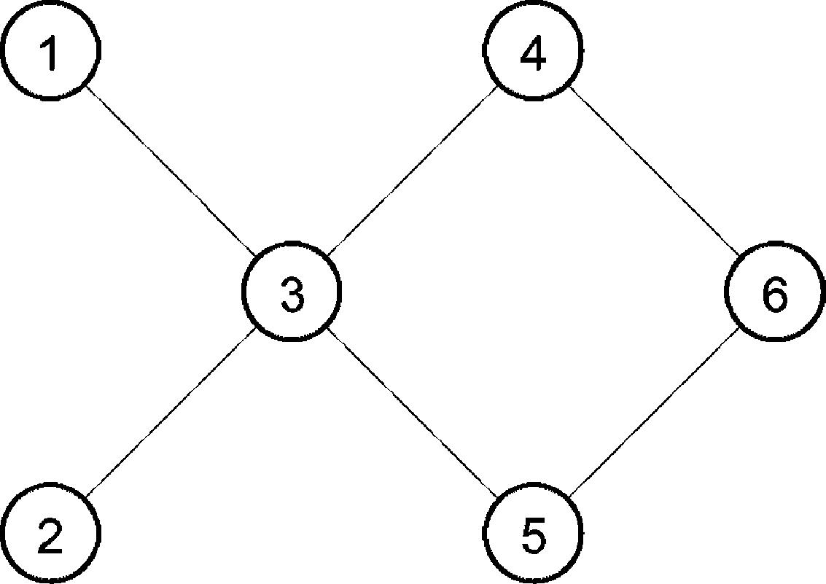

J.E. Burns et al. / Performance Evaluation 52 (2003) 133–152

Fig. A.1. The “Fish” network.

151

Let fP denote the ﬂow on path P . We can assign any ﬂow x where 0 ≤ x ≤ 0.5 to path (1, 3, 4, 6)
whereupon the ﬂows assigned to other routes are
f₍1,3,4,6) = z, f₍1,3,5,6) = 0.5 − z, f₍2,3,4,6) = 1.0 − z, f₍2,3,5,6) = 0.5 + z.
It is probably an advantage for a S–D pair to have two paths rather than one path. Having four paths rather
than three is probably a disadvantage. Operational requirements may prefer a particular value of z. Thus
z = 0 and 0.5 will reduce the number of paths from 4 to 3. The FD algorithm yields z = 0.25 which
assigns two paths from each of nodes 1 and 2 to node 6 with equal bandwidth. From the point of view of
robustness under trafﬁc forecast error, this may be the preferred solution.
Given the link ﬂows, we need methods to compute not only a set of paths and a set of path ﬂows
consistent with the link ﬂows, but we also need criteria to determine which set of paths and path ﬂows are
superior, and we need mechanisms to ﬁnd optimal (according to those criteria) path sets and path ﬂows.

References

[1] Consult http://www.ietf.org for MPLS RFC and Draft Documents such as RFC 3031 (MPLS Architecture), RFC 3036
(LDP Speciﬁcations), RFC 2702 (Requirements for Trafﬁc Engineering over MPLS).
[2] D. Bertsekas, R. Gallager, Data Networks, 2nd ed., Prentice-Hall, Englewood Cliffs, NJ, 1992.
[3] A. Kershenbaum, Telecommunication Design Algorithms, McGraw-Hill, New York, 1993.
[4] L. Kleinrock, Queueing System, Vol. 2: Computer Applications, Wiley, New York, 1976.
[5] S. Floyd, V. Jacobson, Random early detection gateways for congestion avoidance, IEEE/ACM Trans. Network. 1 (4) (1993)
397–413.
[6] T.J. Ott, T.V. Lakshman, L.H. Wong, SRED: stabilized RED, in: Proceedings of the IEEE INFOCOM’99, 1999,
pp. 1346–1355.
[7] Trafﬁc Engineering and QoS Methods for IP-, ATM- and TDM-based Multiservice Networks.txt. http://www.ietf.org/
internet-drafts/draft-ietf-tewg-qos-routing-04.txt.
[8] C. Villamizar, http://brookﬁeld.ans.net/omp/random-test-cases.html.
[9] A.B. Bagula, A.E. Krzesinski, Trafﬁc engineering label switched paths in IP networks using a pre-planned ﬂow optimization
model, in: Proceedings of the Ninth International Symposium on Modeling, Analysis, and Simulation of Computer and
Telecommunication Systems (MASCOTS’2001), Cincinnati, USA, August 2001, pp. 70–77.
[10] W.H. Press, S.A. Teukolsky, W.T. Vetterling, B.P. Flannery, Numerical Recipes in C, 2nd ed., Cambridge University Press,
Cambridge, 1992.
[11] R. Bhandari, Survivable Networks: Algorithms for Diverse Routing, Kluwer Academic Publishers, Dordrecht, 2001.
[12] T. Carpenter, K.R. Krishnan, D. Shallcross, Enhancements to trafﬁc engineering for multi protocol label switching, in:
Proceedings of the ITC17, Salvador, Brazil, September 2001.
[13] V. Sharma, et al., Framework for MPLS-based recovery. draft-ietf-mpls-recovery-frmwrk-03.txt.






152

J.E. Burns et al. / Performance Evaluation 52 (2003) 133–152

James E. Burns is a Research Scientist in Applied Research at Telcordia Technologies. He is an ac-
knowledged expert in distributed computing systems, especially in regard to self-stabilizing systems, a
specialized area within fault tolerance. He has been involved in developing and simulating protocols for
new and evolving areas, with an emphasis on next generation networks. An important part of this work
is the analysis of live network trafﬁc in order to understand the complex interactions of different protocol
mixes over the Internet. Recently, Dr. Burns has investigated the design and practical use of multicasting
protocols for specialized applications. Degrees: BS, Mathematics, California Institute of Technology;
MBIS, Business Information Systems, Georgia State University; MS, Georgia Institute of Technology;
Ph.D., Information and Computer Science, Georgia Institute of Technology.

Teunis J. Ott (Teun) is Professor in Computer Science at the New Jersey Institute of Technology. Prior
to joining NJIT in 2001 he was for 23 years MTS, Supervisor, Director, and Senior Scientist at Bell
Laboratories, Bellcore, and Telcordia.
In the late 1970s and 1980s Teun published extensively in Queueing Theory and Applied Probability.
Then he switched to computer networking. For the readership of this journal his best known publication
is an 1996 unpublished paper with Joop Kemperman and Matt Mathis that established the Square Root
Formula for TCP (http://web.njit.edu/∼ott/Papers/index.html, etc.). Teun has six patents in the area of
routing, transport and control in IP and ATM, etc.

Anthony E. Krzesinski obtained the M.Sc. from the University of Cape Town and the Ph.D. from
Cambridge University, England. In 1972, he joined the Shell Research Laboratory in Amsterdam where
he worked on the development of mathematical models to predict the performance of computer systems.
In 1975, he joined the Department of Computer Science at University of Stellenbosch. In 1985, he was
appointed as Professor of Computer Science at the University of Stellenbosch. His research interests
centre on the performance evaluation of telecommunication networks.

Karen E. Mьller holds the B.Sc. in Mathematics and Computer Science, the B.Sc. Honors in Computer
Science and the Higher Education Diploma all from the University of Stellenbosch. She is currently
completing her M.Sc. in Computer Science at the University of Stellenbosch.

